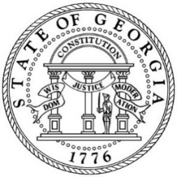

BOARD OF HUMAN SERVICES

Microsoft Teams Live Meeting

November 18, 2020
9:30 a.m. – 12:00 p.m.

- Program Reports 9:30 a.m. – 10:20 a.m.

  - Division of Aging Services (DAS) Update Abby Cox, Director, DAS

  - Division of Child Support Services (DCSS) Tanguler Gray, Director, DCSS
Update

  - Division of Family and Children Services (DFCS) Tom Rawlings, Director, DFCS

- Break 10:20 a.m. – 10:30 a.m.

- Administrative Reports 10:30 a.m. – 11:00 a.m.

  - DHS Ethics Officer Overview Ann Burris, Assistant Deputy
Commissioner, Office of Human Resources

  - DHS COVID-19 Update Gerlda Hines, Chief of Staff, DHS

- Legal and Public Policy Reports 11:00 a.m. – 11:30 a.m.

  - Safe Place for Newborns Act Rule Change Stephen Harris, General Counsel, DHS
  - Regulatory Effort Rule Changes Stephen Harris, General Counsel, DHS
  - Residential Child Care Licensing Rule Change Pamela Carr-Cosby, Associate General
Counsel, DHS

- DFCS Rule Changes Chris Hempfling, General Counsel,
DFCS

- Call to Order 11:30 a.m.
Ms. Tiena Fletcher, Chair

- Attendance Report Brooklyn Ealey
Special Assistant to Commissioner

- Approval of Minutes Ms. Tiena Fletcher, Chair
  - August 26, 2020

- Action Items for Consideration by the Board Ms. Tiena Fletcher, Chair
  - 2021 Board of Human Services Meeting Schedule
  - Safe Place for Newborns Act Rule Change
  - Regulatory Reduction Effort Rule Changes
  - Residential Child Care Licensing Rule Changes
  - DFCS Rule Changes

- Commissioner’s Report Robyn A. Crittenden, Commissioner

- New Business and Closing Comments Ms. Tiena Fletcher, Chair

- ADJOURN

All times are approximate.
The next DHS Board Meeting is Wednesday, February 10, 2021.

