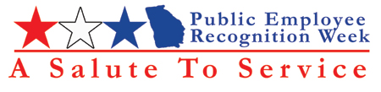



Public Employee Recognition Program Guide and Nomination Form

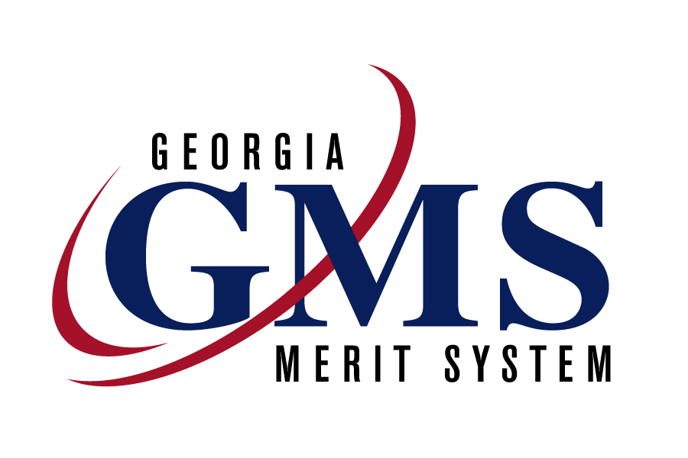

Table of Content

Purpose 3

Occasion 3

Awards Introduction 3

Eligibility Criteria 3

Nomination Process 4

Selection Process 4

Project Timeline 5

Award Categories 6-8

Nomination Instructions 10

Nomination Form 11

Suggested Activities 13-14

Purpose:

The purpose of the Public Employee Recognition Week is to celebrate the achievements and dedication of government employees.

Occasion:

On Wednesday May 4, 2005, a ceremony will be held, at the Freight Depot in Atlanta, to honor award recipients for their outstanding service and dedication. Since space is limited, only the winners will be invited to attend the luncheon ceremony. Therefore, all state agencies are encouraged to observe the week by sponsoring recognition activities that celebrate the accomplishments of staff and their contributions to state service.

Awards Introduction:

All award nominations will be for meritorious service, outstanding performance, a special act or distinguished accomplishment. The nominations should describe the specific impact the recipient’s accomplishment had on the agency, the state or its citizens. The performance upon which the selection is based must be clearly above and beyond that which would be expected from an employee who is fully and competently discharging all of the duties and requirements of their job.

Eligibility Criteria:

Eligibility requirements are as follows:

- Nominee must have been a full or part-time, benefits eligible employee and actively performed duties within the calendar year (January 1-December 31, 2004).

- Nominee cannot be an elected official, member of the judiciary or
an agency head.

- If nominee is deceased, retired or on leave-without-pay, accomplishment must have occurred during active State employment.

- Nominee’s performance must be clearly above and beyond that which would be expected from an employee who is fully and competently discharging all of the duties and requirements of their job.

Nomination Process:

The Georgia Merit System distributes the Program Guide and the Nomination Form, which includes instructions for completing the nomination form, to all state agencies through the Public Employee Recognition Coordinators or HR departments. The information is also available on the GMS website at www.gms.state.ga.us or you may contact the Georgia Merit System, Customer Service Division, Ms. Sharon Angel at 404-657-5927 or by email at sangel@gms.state.ga.us. For DHR employees, please address questions to Kaneisha Smith at 404-651-6549 or Clyde Beckley at 404-463-6253.

The Department of Human Resources will receive nominations forms until 5:00 p.m., Monday, March 14, 2005. No postmarks will be accepted.

Completed nomination packets should be submitted to the DHR’s Public Employee Recognition Coordinator, Kaneisha Smith, or to the following agency representatives:

Division of Aging Services: Jennifer Hogan, jehogan@dhr.state.ga.us , 404-657-9589
Division of Family & Children Svcs: Vicky Frazer, vlfrazer@dhr.state.ga.us , 404-657-5156
Division of Public Health: Carol Hadley, clhadley@dhr.state.ga.us , 404-657-2770
Office of Audits: Adassa Drummond, tadrummond@dhr.state.ga.us , 404-656-9292
Office of Communications: Barbara Joye, brjoye@dhr.state.ga.us , 404-656-4937
Office of Financial Services: Kathi Krieger, kkrieger@dhr.state.ga.us , 404-657-7696
Office of Information Technology: Cathy Whitelaw, cmwhitelaw@dhr.state.ga.us , 404-657-9652
Office of Investigative Services: Mary Hutto, mhutto@dhr.state.ga.us , 404-657-2323

All nominations must be reviewed and signed by the agency head or designee. Electronic signatures are acceptable.

Each agency may submit one nomination form, per nominee and/or team for each category.

Selection Process:

The Awards Review Committee will be chosen from the Statewide Planning Committee. They will review all nominations. The nominations will be grouped according to the award categories. The committee will be responsible for selecting the award recipients. All agency coordinators will be notified in writing when the final selections have been made. The agency coordinators will be mailed invitations for each award recipient, agency head, agency coordinator, nominator and award recipient guests to attend the Awards Luncheon on Wednesday, May 4, 2005.

2005 Public Employee Recognition Week Awards Timeline:

Mail nomination packets February 21

Deadline to submit DHR nominations March 14

Review nominations March 30

Agency coordinators notified by mail April 4

Proclamation Ceremony TBA

Public Employee Recognition Week Begins May 2

State Employee Recognition Ceremony May 4

Public Employee Recognition Week Ends May 8

Award Categories:

Customer Service Award – Employee made exceptional contributions and exceeded expectations in delivering services to external or internal customers. This may be an individual or group who has taken exceptional initiative in “going the extra mile” to provide service to internal and external customers with timely and appropriate follow-up, responsiveness to the needs of all customers and demonstrated improvement of customer service and satisfaction.

Recipient must have provided outstanding performance in working and communicating with internal and/or external customers by providing information, quality services and/or products.

Community Service Award – Through volunteerism or paid community service, employee exhibited dedication by improving the quality of life for members of the community and made program improvements. This may be an individual who has broad-based community involvement, i.e. community or professional boards, service clubs, faith-based organizations, local and national charitable organizations, legal or professional organizations, or political and civic organizations.

Recipient must have provided a service that improved the quality of life for members of the community. Recipient must have provided a service for the community that improved a program and/or service delivery. Recipient may have provided dollar savings or identified new monies to begin a program or service to the community.

Innovations/Suggestions Award – Employee submitted a suggestion that significantly improved procedures. This may have involved an increase in efficiency, a decrease in costs or time, improved public relations, or enhanced internal or external communication. (Previously awarded Employee Suggestion Program participants whose tangible suggestion award savings exceeded $1,000.00 should not be submitted for this award. They will be recognized in a separate category. This category is for first-time innovations/suggestions.)

Recipient must have made a suggestion that significantly improved procedures, increased morale, reduced cost, eliminated duplication or saved lives, time, or money. Recipient may have provided dollar savings or identified new monies to begin a program or service to the community.

Safety Award – Employee created and/or utilized innovative initiatives or approaches to protect and/or ensure the health and safety of state workers or external customers. This may involve an individual or team who has implemented a safety program for the workplace; took an active role in being a strong advocate of safety and health; demonstrated significant improvement over previous conditions; consistently maintained a good safety program or made an extra effort to improve or correct a specific aspect of safety within the workplace.

Recipient must have created and/or utilized an innovative initiative or approach that helped to protect and/or ensure the health and safety of state workers or external customers.

Heroism Award – Employee demonstrated outstanding judgment, courage, self-possession, or ability in an emergency; meritorious action or service to prevent injury, loss of life, or prevent damage to or loss of property. An individual or team may have demonstrated unusual heroism and extraordinary skill or resourcefulness in saving or attempting to save a life at risk to self.

Recipient must have demonstrated unusual heroism, extraordinary skill or resourcefulness in saving or attempting to save a life at risk to self.

Team Award – The team made exceptional contributions with measurable results toward the achievement of the agency’s/division’s goals and objectives. A team must consist of three or more members whose project or initiative is directly related to the mission or goals of the agency or of the work unit. The completion of the project or initiative must have defined goals and utilized strategies for successful completion.

Team must have demonstrated excellent development, implementation or communication skills, showed consideration of others within the team, showed active involvement with stakeholders, demonstrated a willingness to resolve problems and established an identifiable set of goals that were accomplished in an outstanding fashion.

Leadership Award – Employee exemplified and promoted outstanding leadership qualities and behaviors. This individual is blazing a trail for others to follow, “head and shoulders above others” in achieving significant and tangible benefits for the agency or work unit.

Recipient displayed a “can do attitude”; he/she was “head and shoulders above the rest”; he/she empowered their team members; he/she took risks to accomplish the mission; he/she demonstrated significant organizational commitment; and/or increased the team’s or unit’s productivity or outcomes.

Humanitarian Award -Employee or organization demonstrated significant humane concern that was characterized by tenderness, compassion, and sympathy for people or animals, especially the suffering or distressed, that improved the individual(s) welfare, happiness and dignity.

Recipient impacted by providing essential needs to others, such as sanctuary, refuge, emergency foster care or shelter for the abused that alleviated suffering or distress. This individual may have been a person who volunteered to offer his/her professional services to the homeless, rescued needy animals, or provided temporary shelter or relief for abused women and children.

Faithful Service Award – Recognition for years of service in excess of 40 years. *The Georgia Merit System will determine recipients.

Nomination Instructions and Form

Nomination Instructions

The narrative should describe in detail what impact the nominee’s accomplishment made on the agency, the state or its citizens.

Attach a narrative with the following guidelines:

*One full Page

Single Spacing
12-pitch font
Times New Roman
1-inch margins

* Do not exceed the one page limit. Typing on a second page or the back of the page is not acceptable and will not be considered.

The narrative should provide a clear and concise description of the nominee’s achievement and how they provided a measurable benefit to the agency, the state or its citizens.

Nominations must be reviewed and signed by agency head or designee. Electronic signatures are acceptable.

Faxed copies are acceptable, but original should follow in the mail.

All nomination forms should be submitted directly to your agency’s Employee Recognition Coordinator, or to Kaneisha Smith in the Office of Human Resource Management & Development. Failure to submit as indicated could result in your nomination not being accepted at the state level.

DHR will receive nominations until close of business March 14, 2005. No postmarks will be accepted.

If you have any questions, please contact Kaneisha Smith at 404-651-6549 or Clyde Beckley at 404-463-6253.

State of Georgia Public Employee Recognition Nomination Form

(Please return this original form with your nomination information)

Award Category (please circle appropriate cateory)

Customer Service Award Community Service Award
Innovations/Suggestions Award Heroism Award
Safety Award Team Award
Humanitarian Award Leadership Award

Nominee Name or Team Name:
Agency/Division:

Team Member Names:
Please include all members

Nominee’s Business Address:

Name of Nominator:

Nominator’s signature:

Agency Coordinator/HR Manager Signature
Agency Address:

Signature of Agency Head or Designee:

Public Employee Recognition Week

Suggested Activities

Public Employee Recognition Week Suggested Activities for State agencies,
Departments etc.

- Annual Employee Picnic, including a football game against another government agency at one
of the football fields in the city, followed by a barbecue. Health and Safety waivers my need to be issued in order for employees to participate

- Athletic Tournament—an event between divisions and give the winning team an award. Health and Safety waivers may need to be issued in order for employees to participate

- Blood Drive

- Have a mobile DMVS come and renew licenses, ID’s, etc.

- Awards Ceremony within the agency that mirrors the Statewide Program.

- Fun Fair—all agency employees are invited to enjoy an afternoon of food, games, and entertainment

- Unique Game that offers every employee the chance to win lunch with the Department head. Everyone gets a chance to roll cubes; each cube has one letter from the word “Thanks” on a side. If someone spells “Thanks” they win lunch with the Department Head

- 2005 Agency Employee Recognition Week Three-Mile Walk/Run—Health and Safety waivers may need to be issued in order for employees to participate

- Each department can decorate their work area according to their chosen theme

- Crazy hat contest, with prizes for the most creative designs

- Baby Picture Contest—put baby pictures of employees on a poster and have employees to match the picture with the employee. The one with the most matches wins a gift

- Name a continuing recognition award after an outstanding employee, i.e. “The Jane Doe Customer Service Award”

- Write five or more Post-it notes thanking the person for a job well done and hide them among the work on his or her desk

- Name a space after an employee and put up a sign (“The Suzy Jones Corridor”)

- Develop a Behind-the-Scenes Award, specifically for those whose actions are not in the limelight

- Name a parking space after an employee and put up a sign for a designated period of time

- On a public electronic billboard have a message of thanks from the Department Head to all employees for the week

- Have managers give small plastic trophies filled with candy to employees throughout the week

- Agency caps given to all employees with logo

- Provide popcorn and beverages/water throughout the day

- Have an ice cream and cake team building activity

- Invite an elected official to come and speak to employees

- Invite Charities from State Contributions to thank employees for participation

- Live music during lunch

- Have a local high school or college band play for the kick-off event

- Have a motivational speaker for the kick-off event

- Have a display of agency literature and services in the main lobby as part of an “Open House”

- Have teambuilding activities

- Have a banner displayed in the main lobby about employee recognition week

- Give out buttons—2005 Public Employee Recognition Week

For more information on recognition activities or programs, contact Sharon Angel, Georgia Merit System, Customer Service Division, at 404-657-5927 or email sangel@gms.state.ga.us. This information is also available on our website at http://www.gms.state.ga.us/erw/index.asp

Program administered by the Georgia Merit System, Customer Service Division
Peggy D. Rosser, Acting Commissioner

