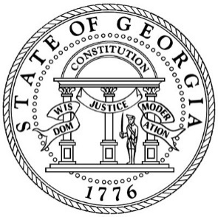
PUBLIC NOTICE

Georgia Department of
Human Services
BOARD MEETING
47 Trinity Avenue SW
Atlanta, GA 30303

May 10, 2023
1:00 p.m. – 4:00 p.m.

Microsoft Teams Meeting
Please visit dhs.ga.gov for the link

