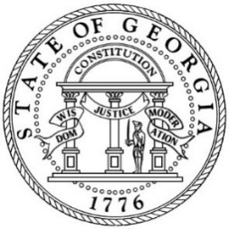

BOARD OF HUMAN SERVICES

DHS Board Meeting Agenda
November 13, 2019 | 1:00 p.m. – 3:00 p.m.

Roosevelt Warm Springs
Georgia Hall Building
6135 Roosevelt Highway
Warm Springs, GA 31830

- Program Reports 11:00 am – 12:00 pm

  - Division of Aging Services (DAS) Update Abby Cox, Director, DAS

  - Division of Child Support Services (DCSS) Tanguler Gray, Director, DCSS
Update

  - Division of Family and Children Services (DFCS) Chris Hempfling, Deputy Division
Update & Rule Changes Director and General Counsel, DFCS
    - Ga. Comp. R & Regs. Chapter 290-1-11
    - Ga. Comp. R & Regs. Chapter 290-2-30

- Break 12:00 pm – 1:00 pm

- Administrative Reports 1:00 pm – 2:00 pm

  - Office of Enterprise Development Update Erica Atkins, Director, Office of
Enterprise Development

  - Benefits Integrity and Recovery Unit Maurice Ingram, Senior Manager, Office
of Inspector General

- Legal and Public Policy Reports

  - Cherokee County Distribution Line Easement Dwayne Daniel, Director, Office of
Facilities and Support Services

- Call to Order 2:00 pm
Ms. Tiena Fletcher, Chair

- Attendance Report Brooklyn Ealey
Special Assistant to Commissioner

- Approval of Minutes Ms. Tiena Fletcher, Chair
  - September 4, 2019

- Action Items for Consideration by the Board Ms. Tiena Fletcher, Chair
  - 2020 Board of Human Services Meeting Schedule

  - Rule Changes
    - Ga. Comp. R & Regs. Chapter 290-1-11
    - Ga. Comp. R & Regs. Chapter 290-2-30

  - Cherokee County Distribution Line Easement

- Commissioner’s Report Robyn A. Crittenden, Commissioner

- New Business and Closing Comments Ms. Tiena Fletcher, Chair

- ADJOURN

All times are approximate.
The next DHS Board Meeting is Wednesday, February 12, 2020.

