The Computer User's Guide
to an
Ergonomic Workstation

March 2004

Office of Human Resource Management and Development

Table of Contents

Introduction 2

Purpose and Scope 3

Chair and Workstation Guidelines 4

Adjusting Your Workstation 5

Maintain Neutral Posture 6

Lighting 8

Vision Care 9

Work Habits 10

Teleworking from the Home Office 11

LaptopTips 14

Musculoskeletal Disorders 15

Workstation Tips 16

Reporting Injuries and Illnesses 17

Exercise Benefits 18

Exercises 19

Questions and Answers 33

Workstation Checklist 35

Internet Resources 38

Special Acknowledgments 39

Introduction

Do you use a computer? Did you know improper posture while using a computer can cause pain?

Ergonomics? What is it?

Ergonomics is the science of fitting workplace conditions and job demands to the capabilities of employees. (US Department of Health and Human Services, Public Health Services, Centers of Disease Control and Prevention, National Institute for Occupational Safety and Health, DHHS (NIOSH) Publication No. 97-117, March 1997)

This handbook is designed to help you set up your workstation and develop work habits to prevent pain and injuries associated with the use of the computer. These injuries are called cumulative trauma disorders, repetitive motion injuries, or musculoskeletal disorders. This book describes the various types of musculoskeletal disorders.

There are many factors that affect whether you’ll experience physical problems related to computer use. Awkward position, repetitive motion, and forceful activities are the most common factors. There are several tips in this handbook to correct the awkward positions and various other situations that can cause you pain. Your comfort and preventing injuries are the focus of this handbook. Work with your manager/supervisor to get your workstation properly adjusted to fit you.



Purpose
The purpose of this handbook is to provide all employees with information to reduce personal injuries and occupational illnesses associated with computer use.

Scope

This guide reflects general industry safety guidelines that promote safe workstations for employees who work at computers by:

(a) Informing employees on ways to adjust a computer workstation to maintain the body in a neutral position.

(b) Informing employees of preventive measures such as proper work habits and exercises to relieve tension associated with computer use.

This handbook is not intended to require that every computer user be issued furniture, equipment, and accessories for their workstation. Purchases are subject to individual department approval processes and budget constraints.

Chair and Workstation Guidelines

There are health benefits to keeping your chair and workstation adjusted to the type of work you are doing. All the adjustments help place the body in a neutral and comfortable position while working. This simply provides good posture and work habits that help you avoid developing painful musculoskeletal disorders.

The types of chairs and workstation adjustments vary considerably. Become familiar with how to adjust your chair and workstation. You may need assistance. Here are some recommendations.

Adjusting Your Chair

- Adjust your chair to a comfortable height with your feet flat on the floor. If you are unable to adjust the chair so that your feet are flat on the floor, you may need a footrest.

- Adjust your backrest height so that it fits the small of your back (lumbar curve) and feels comfortable.

- Adjust your backrest to tilt in or out to support your body in an approximately upright position (readjust for different tasks such as typing, reading, or writing.)

- Set your seat pan depth and angle so there is no pressure on the back of your knees or thighs.

- Adjust the armrests to support your forearms with the shoulders in a relaxed position.

2
1
3
4
5

Adjusting Your Workstation

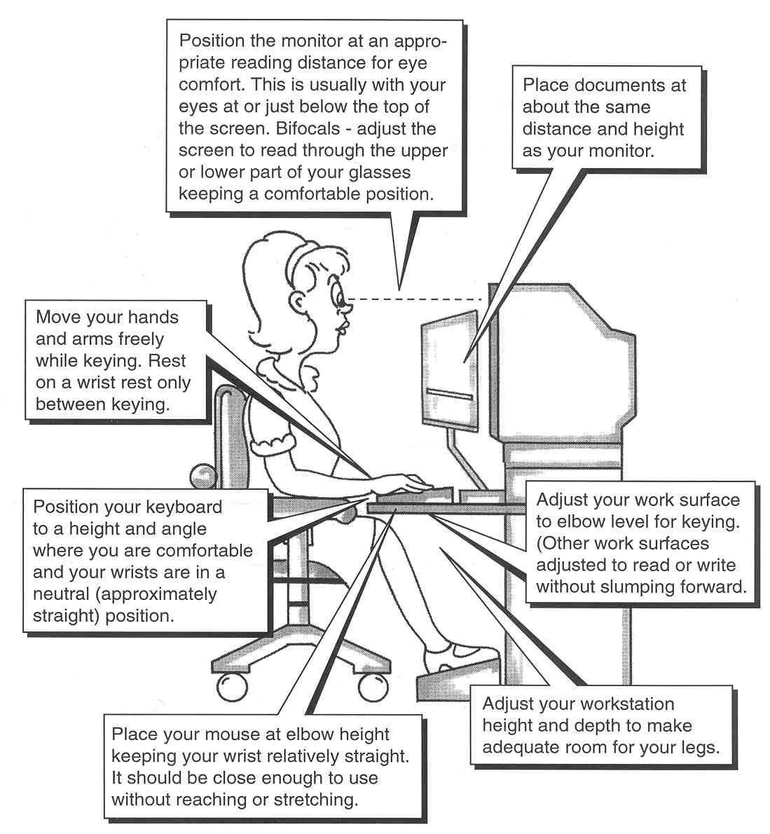

Maintain Neutral Posture

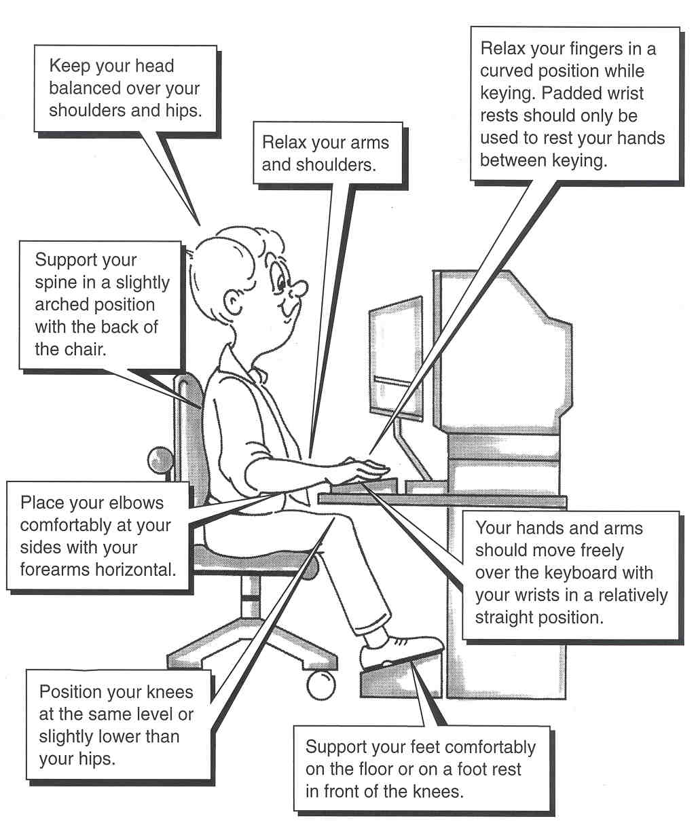

Reach Requirements

When evaluating reach requirements, prioritize items by importance and frequency of use. Items used most frequently should be located in your “near reach zone.”

1. If you frequently use a telephone while at your workstation it should be located within reach (13 to 17 inches). A headset or shoulder rest may be helpful.

2. Source documents should be at the same height, angle, and distance from your eyes as the computer screen. Ideally your documents should be located directly in front of you just below your monitor.

3. Keep frequently used materials and equipment within easy reach (13 to 17 inches).

4. Stand up to reach items above shoulder height or behind you but avoid twisting.

ITEMS USED RARELY
ITEMS USED
MOST FREQUENTLY
13”-17”

ITEMS USED
OCCASIONALLY

Lighting

Simple lighting adjustments can help you minimize glare and reduce eyestrain. Glare can come from a light source such as a light fixture or the sun, or from a bright surface such as a mirror or light-colored work surfaces. The lighting in your entire work area should be at an even level.

1. Lower the total (ambient) light levels whenever possible to reduce glare on your computer screen, i.e., remove or turn off some overhead lighting.

2. Avoid placing your monitor directly under cabinet task lights.

3. Position your screen at a right angle to a window that is producing glare.

- Close shades, curtains, or blinds on windows producing unwanted light or glare.

5. Adjust your monitor display contrast and brightness to improve viewing comfort.

6. Clean your screen periodically to maximize clarity. Characters on your screen should be clear and free from noticeable flicker.

7. Use a hood if necessary to shelter the screen from undesirable lighting.

8. In some situations, nothing else can be done except to use a glare screen. Polarized glass is the best and most costly, polarized film is the next best, and mesh screens are the least desirable because they reduce image quality. Most new monitor screens have a built-in glare guard.

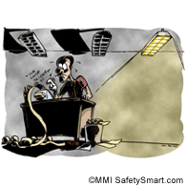
NOT GOOD

Vision Care

Sustained focus on a computer monitor may cause visual and other discomfort. Be alert for the following symptoms: eye fatigue, dry itchy eyes, blurred vision, or headaches.

POSSIBLE CAUSES

1. Overhead lights and bright windows may produce glare.

2. Monitor screen is too close or too far from eyes.

3. Poor display quality, i.e., brightness and contrast need adjustment.

4. Focusing on the monitor for extended periods of time without a break.

PREVENTION TIPS

1. Adjust the computer monitor so that the top tool bar on your screen is at or slightly below eye level.

2. Place your screen at the appropriate reading distance for your eyes.

3. Use a document holder to place documents at approximately the same height as the monitor or, if possible, directly in front of you.

4. Regularly clean your monitor screen.

5. Frequently change focus from your work to an object at least 20 feet away.

6. Have your eyes examined regularly by a licensed optometrist or ophthalmologist. It is recommended annually.

7. You should stretch every 30 - 60 minutes and change positions regularly. The eye exercises below will help alleviate fatigue.

EYE EXERCISES

1. Blinking – Blink frequently to moisten and relax your eyes.

2. Eye and Temple Massage – Using your fingertips, gently massage the bony area around each eye using short circular motions. Do the same for the area around your temples.

Work Habits

Even the best posture and a well-organized workstation will not prevent muscular stress and fatigue if you sit for several hours in one position. Breaks from computer work can help keep your eyes, mind, and body refreshed and energized.

1. The National Institute for Occupational Safety and Health (NIOSH) recommends interrupting computer work with a short break every couple hours. (Check with your supervisor for your break schedule.)

2. Experts also suggest brief, frequent "microbreaks." These breaks are defined as time spent doing something other than work on a computer. It does not have to involve leaving your workstation. Suggestions include moving around, stretching, doing non-computer tasks, and refocusing your eyes.

The timing of such microbreaks is more important than the length. To be the most effective, a break should be taken before the onset of fatigue, rather than recuperating from it. (See pages 18 – 31 for exercises.)

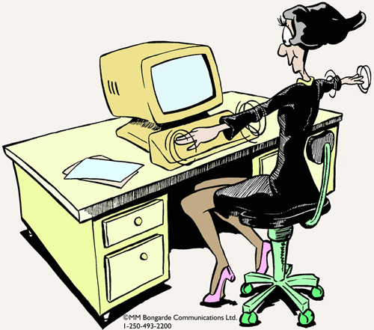

Teleworking from the Home Office

Telework is an off-site arrangement permitting you to work in or near your home for all or part of the workweek. It can also mean working at a project site or in a client's office. This is not a new work option. Improvements in telecommunications and electronic technologies have enabled the State and other employers to move the work to the worker instead of requiring individuals to commute to work every day. Our interest here is your health and safety if you’re working from a home office, which represents an extension of your employer’s office.

The major difference between the employer's office and your home office is ownership and control over the workplace. A telework agreement between the employer and you should reflect the importance of health and safety in the home office along with good ergonomic guidelines. Your department should provide training to better ensure a healthy, safe, and ergonomically sound home office environment.

Remember that it is your responsibility to maintain a healthy and safe work environment in your home. In addition to the checklist in this guide, be sure your fire alarms and fire extinguishers are functional. You should also have an emergency evacuation plan in case of emergency. Once your home office is set up, you should complete a health and safety checklist of your home office.

If you have questions, contact your Division/office Telework Coordinator.

What you, the teleworker, can do to ensure a healthy and safe home office:

- Plan and design your office space by preparing a scale model using graph paper and scaled cutouts for office furnishings and equipment you expect to use.

- Consider doors, windows, lighting and electrical outlets in the layout.

- Set-up your computer work area using the guide on pages 3 and 4.

- Check yourself by completing the workstation checklist. (See pages 34 – 36.)

- Assess your work area anytime you make furniture, equipment, electrical or lighting changes.

MAKE SURE YOU HAVE ADJUSTED YOUR EQUIPMENT TO PROPERLY FIT YOU.

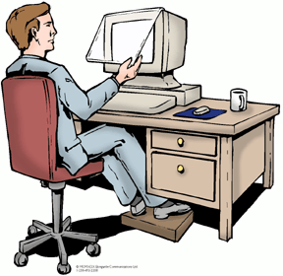

Be Responsible, Be Safe

GOOD!


NOT!

Laptop Tips

Laptops have become a very useful tool for teleworkers and field workers. They are used in hotel rooms, on airplanes, in cars (not while driving, of course), at other work locations, and at home. Laptops are also used as the primary computer at work, off site, and at home. Here are some tips to ensure a safe work environment while using a laptop computer.

1. Use an external mouse and keyboard if working at home or other convenient locations. Arrange your workstation and computer as close as possible to the illustrations on pages 3-6.

2. Find a comfortable position that places the laptop screen as close to eye level as possible and your arms in a comfortable neutral position.

3. Eliminate glare where possible by using shades, turning off extra lights, or changing positions.

4. Use a docking station if the laptop is used as the main computer at work also. The laptop becomes the computer-processing unit (CPU) and allows you to work with a full size monitor, keyboard mouse, trackball, touch pad, or other pointing device.

5. Stretch often, especially if working in awkward space such as an airplane or a hotel room.

6. Give your eyes a break: close them or cover them with your hands for 30 seconds before they feel strained.

7. Use proper lifting techniques when moving the laptop and other equipment, especially in and out of vehicles. Avoid twisting or turning while lifting.

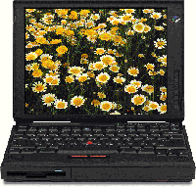

Musculoskeletal Disorders

Musculoskeletal disorders are caused by repetitive motions, excessive force, vibration, exposure to cold, awkward positions, and over exertion. Arms and hands are especially vulnerable. These disorders can involve nerves, blood vessels, or tendons, which connect muscles to bones. Here are some examples.

Carpal tunnel syndrome is a nerve disorder resulting from pressure on the median nerve where it passes from the forearm through the carpal tunnel in the wrist and into the hand. When irritated, the sheaths that surround the tendons in the narrow tunnel can swell and press against the nerve. Symptoms include pain in the front of the wrist and hand, numbness and tingling in the thumb, first two fingers, and half of the ring finger. The symptoms often are worst at night. These symptoms are often treated using physical therapy and anti-inflammatory medication. Surgery may be necessary but only as a last resort.

Tendinitis is an inflammation of a tendon that can occur from excessive pulling or extensive force on the tendon, or if the tendon is in an awkward position. Common symptoms include localized swelling and tenderness over the tendon, pain with exertion, and pain if the tendon is over-stretched.

Tenosynovitis is the swelling of the sheath surrounding a tendon, which contains a lubricant called synovial fluid. Repeated motions may stimulate the sheath to produce excess fluid, which accumulates and causes pain in the sheath.

Thoracic outlet syndrome is compression of the nerves and blood vessels between the neck and shoulder. Symptoms include numbness in the fingers and tingling in the arm.

Ulnar neuritis is a nerve inflammation that results from pressure on the ulnar nerve over time, including leaning on the elbow on hard or sharp surfaces for long periods. Symptoms include tingling and numbness in the small finger and ring finger.

Workstation Tips

Neck
Is your computer monitor too low?
- Raise it using a monitor stand, the CPU, telephone books, or other stable objects so the top tool bar is at or just below eye level.
Do you wear bifocals?
- Lower your monitor so that the screen is visible in the reading portion of your glasses and your neck is in a neutral position.
Are you working with your neck bent forward?
- Consider a slant board for reading and writing.
Do you use a telephone frequently?
- Use a headset.

Shoulders
Is your work surface too high?
- Lower the work surface, if possible. If not, you can raise your chair and use a foot rest if necessary. Your keyboard should be at or just below elbow level.
Are you doing a lot of reaching?
- Bring objects closer to you (within 13-17 inches), or stand up to reach. You can move your chair under your keyboard or use a keyboard tray. If you use a mouse, it should be close and at the same level as the keyboard.

Elbow
Do you have a forceful grip when using your mouse or other tools?
- Relax your hand over your mouse and gently click. Use a pen sleeve, grip or foam from a soft plastic hair curler to extend the grip on your pen or pencil.

Wrist/Hand
Avoid forceful gripping. Keep wrists in a neutral position for typing or tool use, not bent forward, backward or sideways. Rest your hands between keystrokes or periodically when writing.

Thumb
Use pen sleeves and grips. Use electric staplers and avoid pinch-type staple removers.

Upper Back
Avoid long reaches. Avoid slouching and make sure you have good lumbar support. Recheck your upright posture every 20 - 30 minutes after standing and stretching. If your chair has armrests that are too low or too far away from your body, wrap foam, a towel, or a cervical collar (available at drug stores) around them to widen and raise the armrest.

Eye Strain
Position the computer screen so that the least amount of light falls directly on it. If fluorescent lights are causing the glare, have every other bulb removed from the fixtures or shut them off. A glare screen or a screen hood can be used. Use mini blinds or other adjustable window coverings to control the amount of daylight entering your office at various times of the day.
Reporting Injuries and Illnesses

Musculoskeletal disorders or any other illness or injury you believe is work related should be reported to your supervisor. Early reporting results in more successful treatment of these symptoms.

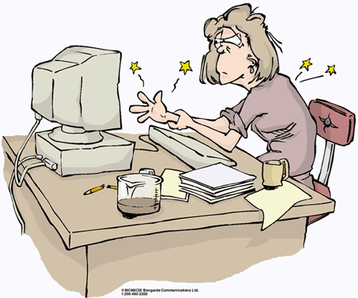

Report Injuries to Your Supervisor.

Some Benefits of Exercise

Exercise should be an integral part of every ergonomics program, especially general exercise such as walking, running, bicycling, or swimming. Stretch and strengthen exercises are also critical to preventing musculosketal injuries. This does not minimize the need for properly adjusted workstations. The combination of ergonomics, exercise, and good nutrition is very successful in preventing musculoskeletal disorders.

Benefits

- Increased circulation;

- Improved general health;

- Increased alertness and concentration;

- Improved posture by increasing body awareness;

- Improved potential to prevent and/or eliminate muscle and joint pain; and

- Improved potential to prevent cumulative trauma disorders.

Exercises

Eye Exercises

Cup Them

- Cup your hands and place them lightly over your closed eyes.

- Hold for a minute, while breathing deeply in and out.

- Slowly uncover your eyes.

Roll Them

- Close your eyes and slowly roll your eyeballs clockwise all the way around. Repeat three times.

- Now slowly roll them all the way around counterclockwise. Repeat three times.

Look Away

- Look away from the computer screen every half hour.
.
- Focus on an object at least 20 feet away.

- Look back at the screen, then look away and focus again.

- Repeat three times.

ALWAYS stretch gently using controlled movements. If you experience discomfort or pain, discontinue and consult a health care professional. If under care, check with your health care professional prior to doing these exercises.

S-t-r-e-t-c-h-i-n-g Exercises

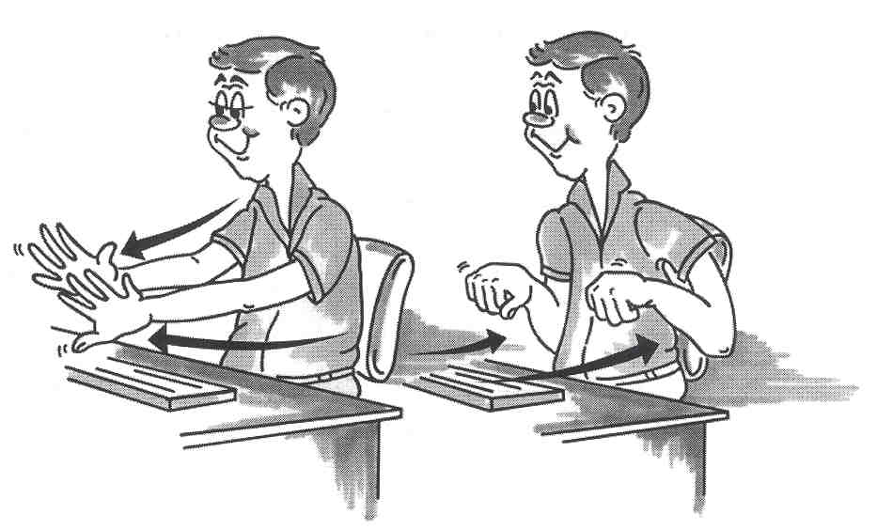

HAND, ELBOW, AND SHOULDER

While sitting or standing:

- Gently push elbows back with arms parallel to the floor;

- Push palms forward while extending arms;

- Spread fingers apart; and

- Repeat three times.

Be sure you have enough room before stretching.

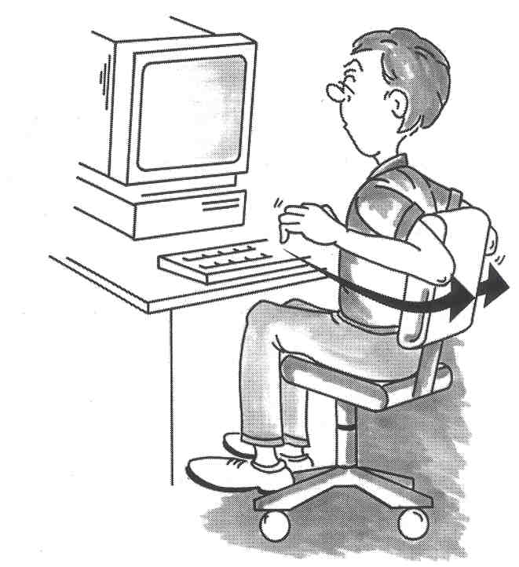

SHOULDERS

While sitting or standing:

- Push elbows back.

- Hold for 5 seconds.

- Repeat 3 times.

Be sure you have enough room before stretching.

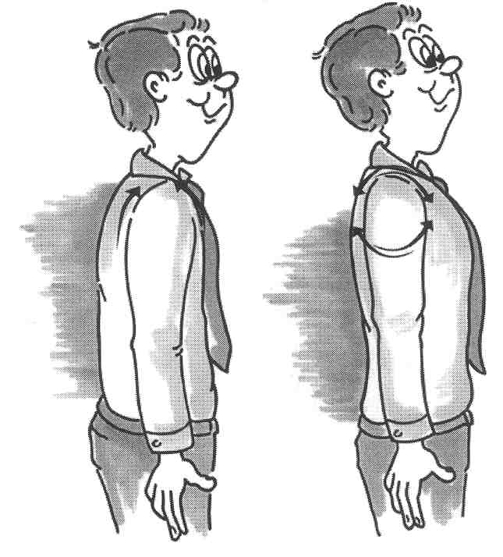

SHOULDERS

While sitting or standing:

- Relax shoulders.

- Roll them forward 5 times.

- Roll them backward 5 times.

- Repeat as needed.

Be sure you have enough room before stretching.

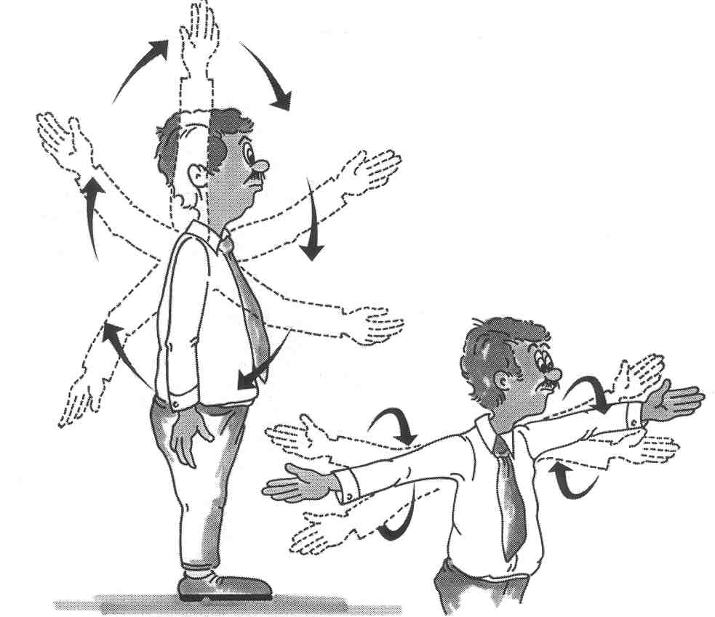

SHOULDERS

- Stand and stretch arms outward.

- Make small gentle circles with your arms.

- Repeat 5 times.

- Advance to larger arm circles.

Be sure you have enough room before stretching.

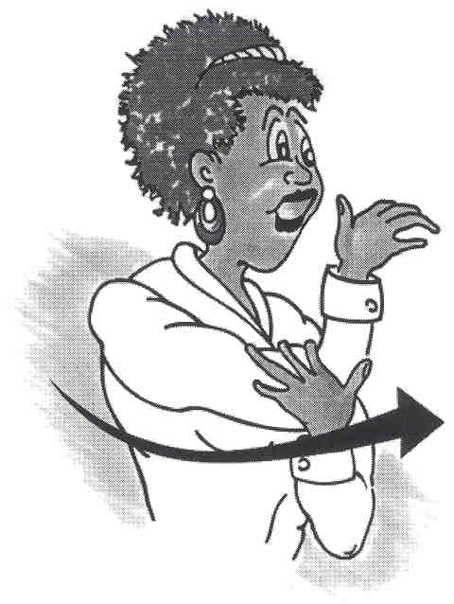

TRICEPS

While sitting or standing:

- Bring one arm in front of you and bend your elbow while placing hand over opposite shoulder.

- Gently push elbow toward chest for about 20 seconds.

- Repeat with the other arm.

- Repeat as needed.

Be sure you have enough room before stretching.

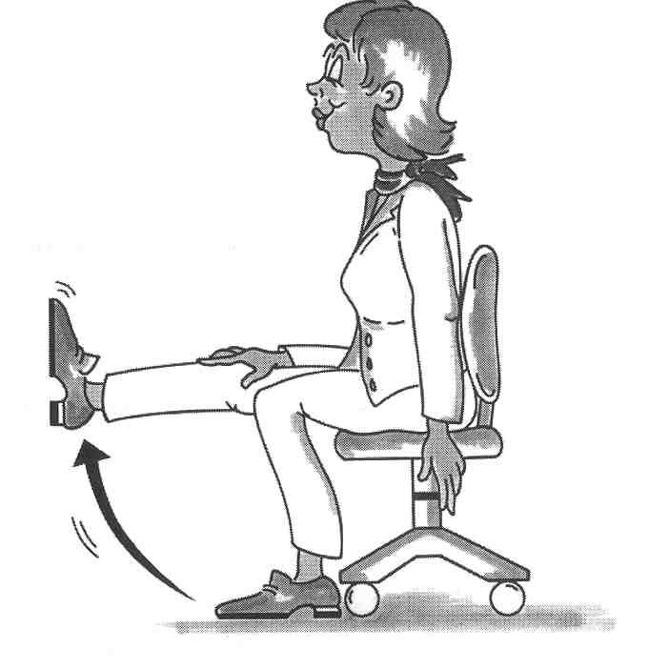

LEGS

- With your back supported by a chair, extend leg.

- Flex your foot and raise leg.

- Repeat with other leg.

- Repeat as needed.

Be sure you have enough room before stretching.

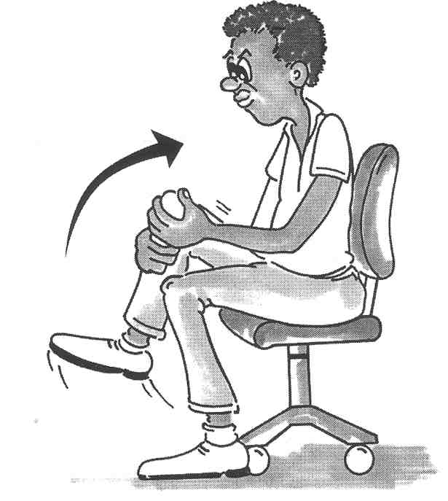

LEGS

- With your back supported by a chair and one foot on the ground, use both hands to gently pull your knee toward your chest.

- Hold for 5 seconds.

- Alternate legs.

- Repeat 3 times.

Be sure you have enough room before stretching.

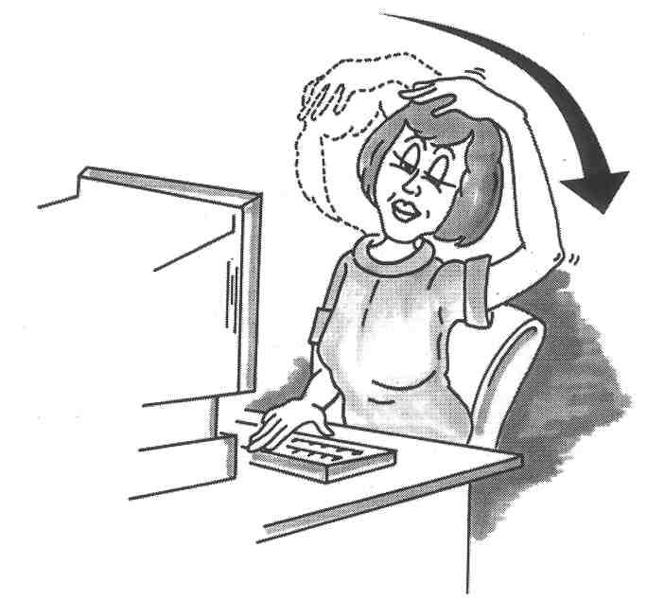

NECK

- Place your right hand on your head.

- Let your neck gently stretch toward the shoulder.

- Hold stretch for about 20 seconds.

- Repeat 3 times on each side.

Be sure you have enough room before stretching.

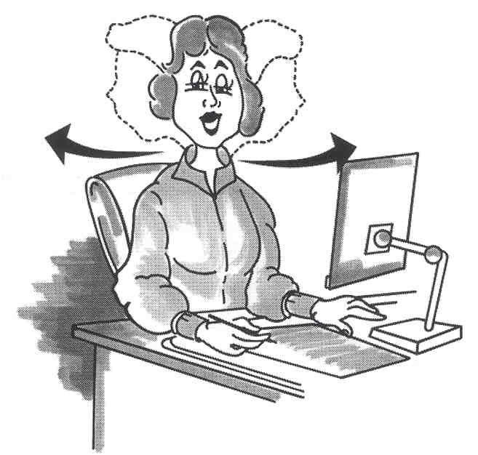

NECK

- Turn your head and look over your shoulder slowly and gently.

- Hold for 5 seconds.

- Repeat 3 times on each side.

Be sure you have enough room before stretching.

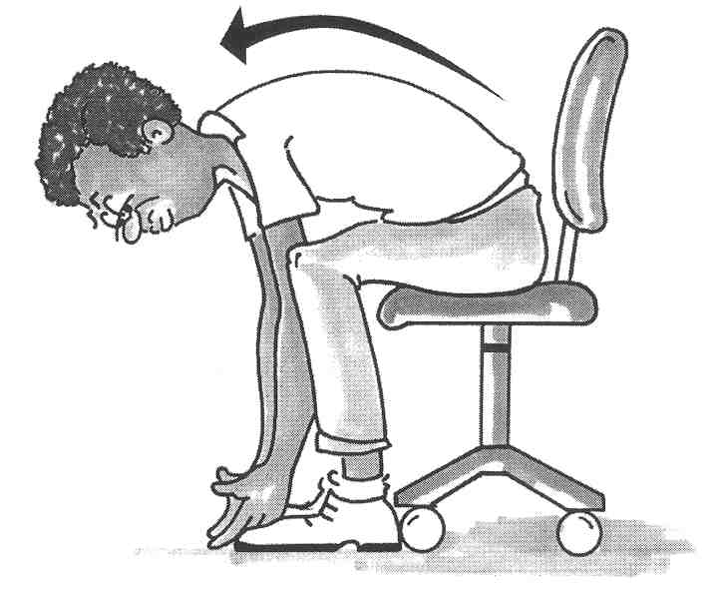

LOWER BACK

- Push your chair a full arm stretch away from your desk.

- Lean forward and try to touch the floor.

- Return to sitting position.

- Repeat as needed.

Be sure you have enough room before stretching.

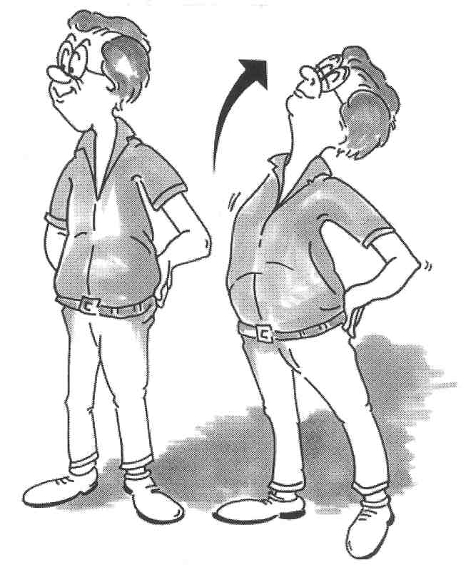

LOWER BACK

- Stand with your hands supporting your low back.

- Gently arch your back.

- Hold for 5 seconds.

- Repeat as needed.

Be sure you have enough room before stretching.

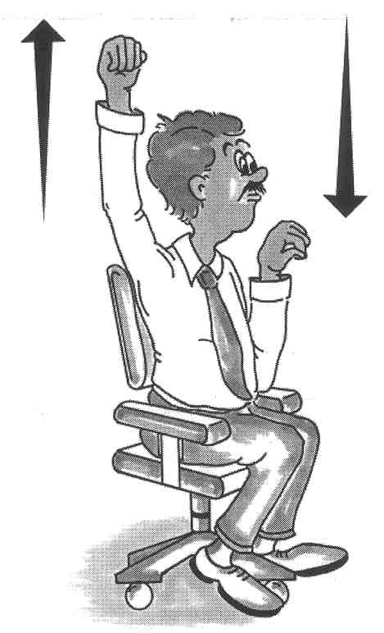

UPPER BACK AND SHOULDERS

- Move one arm overhead and then the other in a climbing motion.

- Repeat 5 times.

Be sure you have enough room before stretching.

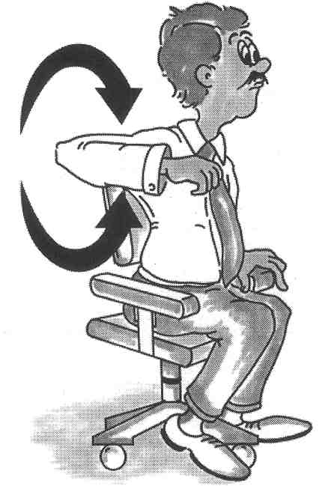

UPPER BACK AND SHOULDERS

- With your right elbow up and bent, circle your shoulder forward and then backward.

- Repeat 5 times on each side.

Questions and Answers

- What can cause musculoskeletal disorders besides computer work?
Any activity that requires repetition, force, awkward posture, static posture (remaining in the same position for extended periods of time), contact stress, temperature extremes, or vibration can cause these disorders. Some medical conditions and genetic factors are also contributing causes.

ACTIVITIES

- removing large numbers of staples
- chopping vegetables
- mechanical work
- gardening
- needlework
- making jewelry
- sports, such as tennis, golf, baseball or bowling.
- car repair

MEDICAL AND GENETIC

- systemic diseases
- congenital defects
- acute trauma
- pregnancy, oral contraceptives, menopause and gynecological surgery
- vitamin B-6 deficiency
- wrist size and shape
- diabetes
- hypo or hyperthyroid
- smoking

- How can I prevent musculoskeletal disorders?
In addition to the ergonomic suggestions in this handbook, proper nutrition and a good general exercise program are key in preventing musculoskeletal disorders.

- Who can perform workstation evaluations?
Individuals that have read and understand this handbook, as well as those who have completed “Ergonomic Training for Trainers,” can evaluate a workstation. Your coworkers, supervisor, and/or your department safety coordinator can help you use this handbook and the workstation checklist to adjust your workstation so it fits you. (See pages 34 –36 for checklist.)

- What ergonomic equipment and accessories are available to ensure a neutral posture?
Depending on individual departmental procedures and budget considerations, the following are examples of equipment and accessories available:

- Telephone headsets.
- Adjustable workstations.
- Monitor stands.
- Keyboard trays.
- Alternate types of pointing devices.
- Mouse trays or platforms.
- Document holders.

- Slant boards for reading/writing.
- Adjustable chairs.
- Lumbar support.
- Wrist rests.
- Glare screens and monitor hoods.
- Footrests.
- Task lamps.

- What can I use to adjust my workstation in the absence of proper accessories?
Binders can be used for a document holder with binder clips to hold the document. Stable objects such as taped phone books or reams of copy paper can be used to raise monitors and keyboards. A rolled towel can be used for a wrist rest or lumbar support, and foam or a towel can raise the arms of a chair.

- Do I need to sit in the same neutral posture all day?
No. You should vary your activities and position during the day to stimulate circulation and rest overworked muscles. Get up now and then, and vary your activities so you are not in the same position for an extended period of time. Frequent stretching is also recommended whether seated or standing.

- What should I do if I have tried everything in these guidelines and I still have musculoskeletal symptoms?
Discuss the specific problems with your supervisor and seek medical advice and/or treatment, if necessary.

- Can carpal tunnel syndrome reoccur?
Yes, if you continue to work at an improperly adjusted workstation, use incorrect work habits, and/or work with your body in an awkward posture, injuries can reoccur.

- Should I be concerned about electromagnetic fields produced by computers?
No. The research that has been conducted in this area is inconclusive. Studies have made no connection between illnesses and electromagnetic fields from computers.

Workstation Checklist

You should have someone who is familiar with this handbook assist in making any necessary adjustments to your workstation.

NOTE: The goal of this checklist is to obtain a neutral posture while working at your workstation.

O.K. | Not O.K. | CHAIR
❑  1. Adjust the chair height so your feet are flat on the floor with your knees level or slightly lower than your hips. Thighs should be parallel to the floor.

❑  2. Adjust backrest height so that the bump fits into the small of your back.

❑  3. Adjust the backrest angle to a comfortable position.

❑  4. Adjust the seat pan so when seated 2-3 fingers will fit between the seat pan and the back of your leg.

❑  5. Adjust the seat pan tilt.

❑  6. After making all of the adjustments above, readjust the backrest height if necessary.

❑  7. If possible, adjust the chair tilt tension so the chair can easily shift positions to accommodate movement.

❑  8. Adjust armrests to elbow height with shoulders in a relaxed position.

O.K. | Not O.K. | WORKSTATION

❑  1. Make sure the chair has been adjusted.

❑  2. Adjust the keyboard height so it is at or just below elbow level. Adjust angle so the wrists are in a neutral (straight) position.

❑  3. Place the mouse so it can be used without reaching and it is level with your keyboard.

❑  4. Adjust the work surface (writing/reading surface) height so it is at or just above elbow level.

ORGANIZE WORK AREA

❑  1. Place items used most often in your “near reach zone,” 13-17 inches.

A. Place overhead/hanging bins as close as possible. DO NOT reach for and remove large binders from bins while seated.

B. Turn to face material. DO NOT TWIST your torso or trunk when reaching for items.

❑  2. Place all frequently used files within close reach.

❑  3. Place the monitor at a comfortable distance.
(13-30 inches.)

❑  4. Adjust the monitor height so the top tool bar is at or slightly below eye level.

❑  5. Adjust monitor angle to prevent glare.

❑  6. Ideally documents should be on a document holder just below the monitor. If this is not possible, place to the side at the same height and distance as the monitor.

❑  7. If you spend extended period of time on the phone you may want to check into a headset.

O.K. Not
O.K. WORK HABITS

❑  1. Use the wrist rest to rest forearms between keystrokes. Wrists and hands should move freely while typing.

❑  2. While typing move your hand and arm together; use the wrist rest only between strokes.

❑  3. Keep wrists straight when using the keyboard. Adjust the keyboard tray height and angle if necessary to maintain a neutral position.

❑  4. While using a pointing device, avoid awkward positions of the arms, hand, and shoulders. Position the mouse at the same level as the keyboard. A mouse support tray may be used to reduce reaching by allowing a mouse to be used near the keyboard. Mouse platforms or stages can be used to bring the mouse closer if necessary.

❑  5. Use a light touch with the keyboard.

❑  6. Hands should be in a relaxed position on the keyboard.

❑  7. Clean the monitor screen regularly.

❑  8. Change foot position often.

❑  9. Vary your tasks and take frequent microbreaks away from the keyboard and monitor.

❑  10. Change your body position frequently, readjusting your chair as necessary.

❑  11. Stretch often while sitting or standing to avoid muscle fatique.

Internet Resources

- Bad Designs - Table of Contents
- CTDNews - Ergonomics and Workplace Safety
- CUErgo Cornell University Ergonomics Web Site
- DoctorErgo.com
- Ergonomics At Work
- Ergonomics
- Ergoweb - The Trusted Source for Ergonomics
- Ergoworld-Home
- IBM
- Office Ergonomics Training
- overhead projectors, scotch tape and other office supplies from 3M Office
- Para Technologies - Stretch Break home page
- R.S.I. Page
- Typing Injury FAQ Home Page

- http://www.cdc.gov/niosh/ephome2.html / NIOSH – National Institute of Occupational Safety and Health, Elements of Ergonomics Programs.

- http://www.osha.gov/SLTC/computerworkstation/index.html / Federal OSHA, Computer Workstations.

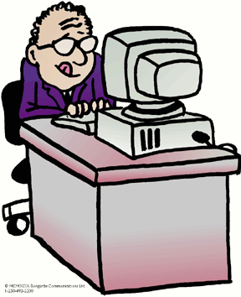

Special Acknowledgments

This booklet is an edited version of the August 2002 revision of the State of California’s guide prepared by:

Sandi Becker
Workers’ Compensation & Safety Coordinator
Workers’ Compensation Program
Department of Personnel Administration

Special thanks to Keith Mentzer and Shelby Wineinger.

Cartoon Graphics by: Bill Malott, Graphic Artist

